

YOUR MOBI PROFILE:

Your Mobi Profile helps us connect you with helpful people and resources.
If the on-line profile form is not an option for you, please use this word form to
- Sign up for the Mobi Monday news
Get the latest information on upcoming competitions, conferences, meet-ups, job opportunities, courses, learning opportunities, and anything else that will help you move forward all the great work you’ve been doing through your enterprise in the field of sustainable transportation.
- Join M.O.D.E. (Mobi Open Databank of Enterprise)
An online databank where you can profile for your organization and find others of like spirit.
- Apply for MobiPrize 2014 (Enterprising City/State Mobi)
Win a cash prize, travel to Detroit, USA for the ITS World Congress for the award ceremony, benefit from great mentorship, and more…

Please return a scanned completed form by email to mobi.internal@gmail.com, or a printed form by postal mail to: Komal Anand, SMART MODE 2901 Baxter Road, Ann Arbor, Michigan 48190-2150.

BASIC DETAILS …
(To receive Mobi Monday News by email most Mondays):

Do you wish to receive Mobi Monday News online most Mondays?
Yes
Not at this time

First Name *

Middle Name

Last Name *

Email Address *

Username *: To create an online Mobi profile account please provide a username between 6 and 10 characters.

Postal Address *

Address Line 2

City *

State/Province

Zip/Postal Code*

Country *

Phone No. *


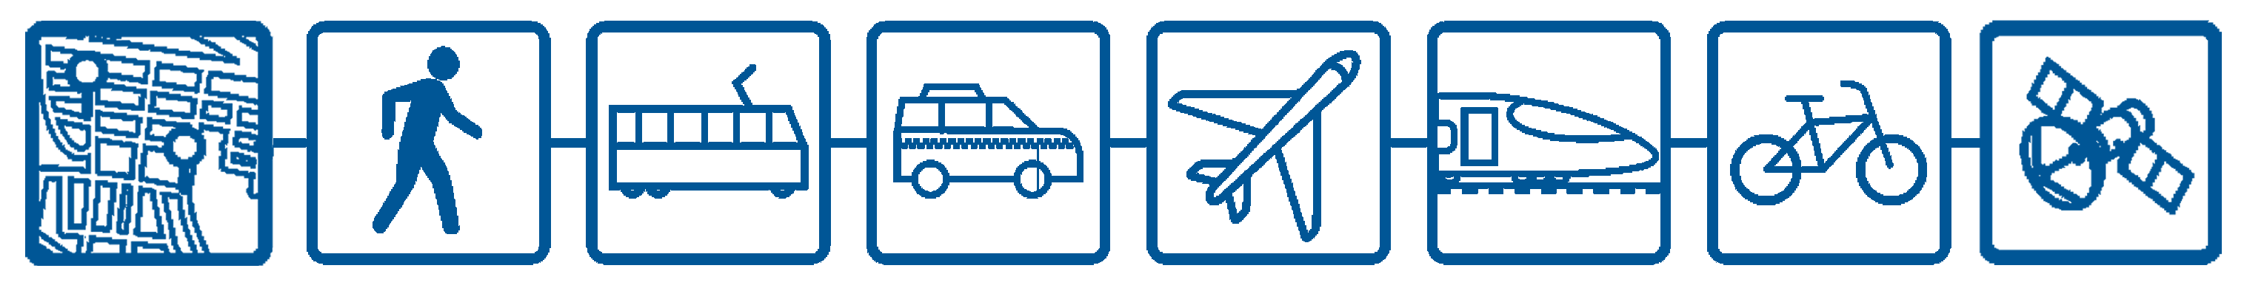
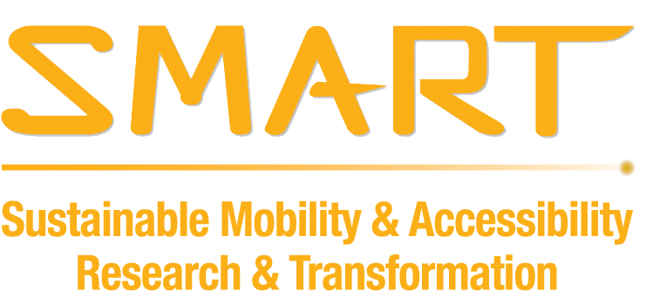
Fax

Skype

A FEW MORE DETAILS …
(for a free Listing in M.O.D.E.- Mobi Open Databank of Enterprise)

Name of your company/organization:

Address of your company/organization if different from above address:

Address Line 1 *

Address Line 2

City *

State/Province

Zip/Postal Code*

Country*

Designated Project Lead:

Job Title

Please insert/paste a picture of yourself and / or your team or provide a link to your image.

What Sector(s) do you associate yourself with?
Private Sector / Large Business
Private Sector / Entrepreneur
Government
NGO
Academic
Citizen / Interested Party / Independent

Would you like to join the Mobi Open Databank of Entrepreneurship (MODE)?
Yes
Not at this time

Which MODE are you?
Enterprise MODE - posts enterprises that are up and running and legal and advance sustainable transportation locally or globally.
Upcoming MODE - posts upcoming and about-to-launch enterprises and entrepreneurs that advance sustainable transportation locally and / or globally.
Catalyzing MODE - posts investors, non-profits, businesses, and government agencies doing great work in support of New Mobility, innovation, enterprise, and entrepreneurship.

If you are a public enterprise then please include proof of company being registered for over 6 months in your application package. For other government entities, please include proof of being a government agency (might include letter on official letterhead, registration proof, etc).
Please insert /paste or provide a link to the image that best describes your venture or focus.
(It could even be your logo.) *

Photo link(s)
Feel free to include links to your additional photo files (Flickr, Picasa, etc)

Video link(s)
Few things convey innovative ideas better than a short video. Please provide link(s) to your uploaded video (YouTube, Vimeo,etc)

Organization Brief (max 250 words) *
Briefly describe your enterprise or organization or project - what challenges and opportunities it addresses; what inspired it; why it is unique; why it is useful; what has been successful; what your goal is / what you plan for the future.

One-Line Description (100 words max) *
Even if you don't apply for or win a MobiPrize, you're still a winner-- all MODE profiles will be posted in the MobiNet to help promote your work world-wide and to link you with customers and investors and other potential partners and supporters. In one line, describe what your product or service is and does, keeping in mind that people will search for you by keyword.

AND JUST A FEW MORE DETAILS … (To Apply for Mobi Prize 2014! *)

Do you wish to apply for Mobi Prize 2014?
Yes
Not at this time (skip this section)

Note that your profile above must be complete in order to qualify.
Before you start, please see JUDGING CRITERIA (http://mobiprize.com/?page_id=279) for the criteria for three different prizes.
Note that we require printed proof that you are an authorized representative of a government agency/department/public enterprise. (This could be a letter on company letterhead, enterprise registration, etc.)

Please confirm you are representing a government entity. *
(Please include proof of being an authorized representative of the government entity)
Yes, I represent a government entity.

1. Does the city or state government/agency/department meet the general goals of Mobi prize? (60 points) *
- How does your encouragement of New Mobility entrepreneurship make transportation and / or urban life more sustainable, more resilient, more convenient, or safer in your community? How does it help achieve the city’s goals?
- Please describe the measures your government/agency/department has taken to build a culture of innovation and to encourage entrepreneurship in sustainable mobility. Here are some possible action areas for your reference:
  - programs/activities supporting a culture of sustainable mobility entrepreneurship
  - incentives – for example prizes, competitions, funds, media recognition
  - capacity building – for example courses, mentorship, training, learning and networking events
  - enabling policy – for example updating current policy, introducing new policy encouraging entrepreneurs
  - data – for example providing access to data or bandwidth, or streamlining data formats
  - providing funding or joint funding or supporting Public Private Partnership
- How does your encouragement of New Mobility enterprise and innovation support integration of modes, services, technologies, and infrastructures with people at the forefront?
- What kinds of entrepreneurial ventures have been supported? If possible, please include names of enterprises for each category checked:
  - transport Services
  - new transport modes
  - transport infrastructure
  - technologies (information, energy, vehicle and other)
  - transport system design
  - transport infrastructures
  - other

2. Is your effort unique or innovative? (30 Points) *
- In what way is your effort an innovative approach to encouraging New Mobility entrepreneurship?
- What differentiates your effort from other similar ones?
- How do the various aspects of your effort and participants in your effort (entrepreneurs, government departments & agencies, NGO’s) connect with each other? Do they contribute to a larger city project?
- How does your encouragement of New Mobility entrepreneurship benefit your local economy?
- What percentage of the entrepreneurs is local and how many are from elsewhere? What do you anticipate the mix will be in the future and what are your goals related to this mix?
- How are citizens involved in these projects?

3. Is the effort replicable/scalable? (30 Points) *
- How possible would it be to adapt, scale up and/or replicate your approach in other locations? Please describe.
- Do you see opportunities for future development and collaboration of your own efforts? Please describe.

4. How does your city/state govt. or govt. agency/public enterprise measure the success? (30 points) *
- What metrics do you use to measure the success of the project? Please describe, and share any relevant results.
- How many people in the city are affected by the project? Is the project aimed at a specific target group(s) in the city?
- Describe diversity of the partnerships you have developed in your effort or campaign to encourage New Mobility entrepreneurship (who were you able to involve?)
- What measures have you put in place to achieve long-term sustainability? Examples:
  - Cross-department support
  - Support across different levels of government – city, state, national
  - Links to big business
  - Partnership with local NGO’s that encourage or support New Mobility entrepreneurs

CHECKLIST BEFORE SUBMISSION
Please make sure all the below items are included and checked before submitting your application.
I declare that I am an authorized representative of city, state or sub-national government or government owned agency/public enterprise.
Proof of being an authorized representative is linked/enclosed.
For public enterprises, proof of being legally registered for over 6 months is linked/enclosed.
A profile picture of the representative/team is linked/enclosed.
A picture that best describes my organization is linked/enclosed.

OFFICIAL RULES & SUBMISSION GUIDELINES
- Organizations submitted must be submitted by or with the written consent of the owner or leader of the organization.
- Organizations submitted must be related to sustainable transportation (New Mobility).
- FOR CITY PRIZE: Applicants must be city, state or sub-national governments or government owned agencies/public enterprises.
FOR GRAND MOBI: Must be for profit businesses (Non Profit/NGO are not eligible to apply) and legally in operation for over 6 months and legally authorized to conduct its business where its operations are located.
FOR MICHIGAN MOBI: Must be for profit businesses (Non Profit/NGO are not eligible to apply) and legally in operation for over 6 months and legally authorized to conduct its business IN MICHIGAN.
- In submitting information, the entrant warrants to SMART that all information is true to the best of her/his knowledge, and agrees that all information submitted can be used and publicized in print and online by SMART for non-commercial use.
- All other copyright rights remain with the owners.
- In submitting photographs of individuals, the entrant warrants to SMART that the entrant has obtained all required rights and permission to photograph and distribute images of the persons and objects in the photograph. Entrant is solely responsible for cases in which the subjects have not granted permission and shall defend and hold harmless SMART for any alleged breach of this warranty.
- SMART reserves the right to disqualify entries that do not conform to the stated rules and guidelines. It is the entrant’s responsibility to ensure that he/she/it has complied with these Official Rules. By participating in the contest, the entrant agrees to be bound by these Official Rules and to provide all reasonable documentation SMART may request to verify the entrant’s compliance with all contest requirements. The determination by SMART of the winners will be final and binding in all matters relating to this contest.
- Entrants are advised that obtaining any required permissions to enter the United States are solely the responsibility of the entrant and SMART accepts no responsibility due to any inability of an entrant to travel to or enter the United States.
- Top finalists will be posted on the website. The winner will be notified via email between July 21st and 25th 2014.
- The Grand Mobi winner will receive a $15000 cash prize, while the Michigan Mobi winner will receive a $5000 cash prize. Both winners will be provided travel to Detroit, USA for the ITS World Congress where they will be awarded and will get interactive time with Mobi Prize mentors.
Yes I agree to these terms and conditions Date: __________________________

Name of Person: _______________________________________________
Name of Organization/Enterprise: _______________________________________________

Signature

